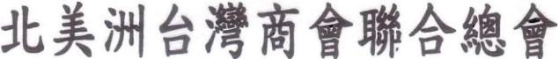
Taiwanese Chambers of Commerce of North America
9315 Bellaire Blvd., Houston, Texas 77036
http://www.tccna.org E-Mail: tccna30@gmail.com

EARTHQUATE DONATION FORM

DATE:
AMOUNT OF CHECK /CASH | $ | CHECK #
DONOR NAME

ORGANIZATION NAME (if applicable)
ADDRESS

Check Make Payable to: TCCNA (EARTHQUAKE RELIEF FUNDS)

Mailing address: 9315 Bellaire Blvd., Houston, TX 77036
Attention: Terry Hou, Public Relations

Please feel free to contact us if you need more information. Thank you for your generous support. TEL: 713-596-6848, 713-596-6872 or email: tccna30@gmail.com

